**BESTENLIST INTERNSHIP PROJECT**

**PRICE COMPARING WEBSITE**

**How to use**

After running this program a window is popped up which asks user to enter the product.

[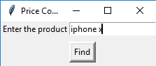](https://user-images.githubusercontent.com/40419750/42380586-114b5d8e-814c-11e8-9147-e24ad9a309a6.png)

After entering the product and clicking on the 'Find' button it will take us to another window which will show the title of the product on both sites and there corresponding prices.

[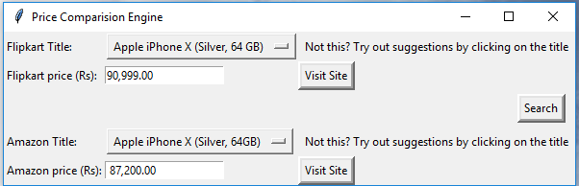](https://user-images.githubusercontent.com/40419750/42381017-687b5cfc-814d-11e8-9312-8a46054e5286.png)

If you didn't get the desired product then click on the title to get suggestions related to your search.

[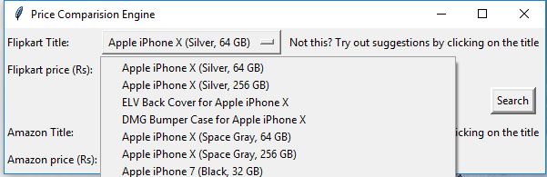](https://user-images.githubusercontent.com/40419750/42381407-90155cd0-814e-11e8-931a-7cef280047cc.png)

Select the desired product from the suggestions for both sites and then click on the 'Search' button to get their corresponding prices.

[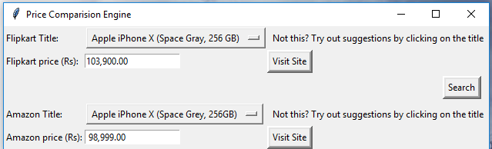](https://user-images.githubusercontent.com/40419750/42381782-cbcb1bd8-814f-11e8-92c2-245ed3f2dc5d.png)

**Highlights:**

1. You can try out suggestions to find other products related to your search just by clicking on the title of the product.
2. By clicking on the 'Visit Site' button, you will be redirected to product's page of that site.

**Tip:**

To avoid 'Product not found', try searching the basic model and then select the desired version of that model instead of searching it with it's specifications.

For Example: Instead of searching 'Apple iPhone X (Space Grey, 256GB)', search 'Apple iPhone X' and then select the desired specifications from suggestions